**Glossary**

**Crypto Academy by Investmate**



[**Checklist Writing Guide** 3](https://docs.google.com/document/d/1iLxhj0aosoWNXvddl-Hrb2UnQBIlm5qFqXfN7pV1gZ4/edit#heading=h.eqdvnxc2lfiy)

[UI Elements 4](https://docs.google.com/document/d/1iLxhj0aosoWNXvddl-Hrb2UnQBIlm5qFqXfN7pV1gZ4/edit#heading=h.jbptjs5cjcin)

[1. Onboarding screens 4](https://docs.google.com/document/d/1iLxhj0aosoWNXvddl-Hrb2UnQBIlm5qFqXfN7pV1gZ4/edit#heading=h.zh85iuunm2ir)

[2. Lessons 6](https://docs.google.com/document/d/1iLxhj0aosoWNXvddl-Hrb2UnQBIlm5qFqXfN7pV1gZ4/edit#heading=h.3a4cuext7nzc)

[2.1. Lessons main screen 6](https://docs.google.com/document/d/1iLxhj0aosoWNXvddl-Hrb2UnQBIlm5qFqXfN7pV1gZ4/edit#heading=h.49nphwmn9mf4)

[2.2. Lesson start screen 7](https://docs.google.com/document/d/1iLxhj0aosoWNXvddl-Hrb2UnQBIlm5qFqXfN7pV1gZ4/edit#heading=h.24uj93ly0xdd)

[2.2.1. Lesson module 8](https://docs.google.com/document/d/1iLxhj0aosoWNXvddl-Hrb2UnQBIlm5qFqXfN7pV1gZ4/edit#heading=h.75x00q39f8p0)

[2.2.2. Quiz module 9](https://docs.google.com/document/d/1iLxhj0aosoWNXvddl-Hrb2UnQBIlm5qFqXfN7pV1gZ4/edit#heading=h.2e4fysl4l7wo)

[3. Articles 11](https://docs.google.com/document/d/1iLxhj0aosoWNXvddl-Hrb2UnQBIlm5qFqXfN7pV1gZ4/edit#heading=h.9wchd6h4y8k9)

[3.1. Article screen 12](https://docs.google.com/document/d/1iLxhj0aosoWNXvddl-Hrb2UnQBIlm5qFqXfN7pV1gZ4/edit#heading=h.ldbb9n8caqip)

[4. Glossary 13](https://docs.google.com/document/d/1iLxhj0aosoWNXvddl-Hrb2UnQBIlm5qFqXfN7pV1gZ4/edit#heading=h.9459npa7kv2l)

[4.1. Term screen 14](https://docs.google.com/document/d/1iLxhj0aosoWNXvddl-Hrb2UnQBIlm5qFqXfN7pV1gZ4/edit#heading=h.o2wz5w2qa3re)

[5. Settings 15](https://docs.google.com/document/d/1iLxhj0aosoWNXvddl-Hrb2UnQBIlm5qFqXfN7pV1gZ4/edit#heading=h.i7y9mll4tvgb)

[5.2.](https://docs.google.com/document/d/1iLxhj0aosoWNXvddl-Hrb2UnQBIlm5qFqXfN7pV1gZ4/edit#heading=h.tyxgrxp9xyad) Application block [[Try our products] 16](https://docs.google.com/document/d/1iLxhj0aosoWNXvddl-Hrb2UnQBIlm5qFqXfN7pV1gZ4/edit#heading=h.tyxgrxp9xyad)

[Capital.com: Trading & Finance 16](https://docs.google.com/document/d/1iLxhj0aosoWNXvddl-Hrb2UnQBIlm5qFqXfN7pV1gZ4/edit#heading=h.qs2a098xraji)

[Investmate: Learn to trade (needs clarification) 16](https://docs.google.com/document/d/1iLxhj0aosoWNXvddl-Hrb2UnQBIlm5qFqXfN7pV1gZ4/edit#heading=h.kew268mr2wf9)

[5.3. Social links 17](https://docs.google.com/document/d/1iLxhj0aosoWNXvddl-Hrb2UnQBIlm5qFqXfN7pV1gZ4/edit#heading=h.xm95se7ajgfu)

[YouTube channel 17](https://docs.google.com/document/d/1iLxhj0aosoWNXvddl-Hrb2UnQBIlm5qFqXfN7pV1gZ4/edit#heading=h.xtvs5u7wib6w)

[TikTok account 17](https://docs.google.com/document/d/1iLxhj0aosoWNXvddl-Hrb2UnQBIlm5qFqXfN7pV1gZ4/edit#heading=h.v9e5zr2atoau)

[5.4. Feedback](https://docs.google.com/document/d/1iLxhj0aosoWNXvddl-Hrb2UnQBIlm5qFqXfN7pV1gZ4/edit#heading=h.5fjs2lnjr61k) block [Give us feedback] [18](https://docs.google.com/document/d/1iLxhj0aosoWNXvddl-Hrb2UnQBIlm5qFqXfN7pV1gZ4/edit#heading=h.5fjs2lnjr61k)

[Rate Us 18](https://docs.google.com/document/d/1iLxhj0aosoWNXvddl-Hrb2UnQBIlm5qFqXfN7pV1gZ4/edit#heading=h.j2ij4kuo0a4e)

**Checklist Writing Guide**

* The button names, links, menu sections, menu items, tabs, cells are written in [square bracket], all other elements, such as block names, columns, rows, screens are written in "quotes".
* If the expected result (ER) has more than one point, the numbered list is used:

1. First part of the expected result
2. Second part of the expected result

* Write "Tap button/link/tab… [element title]"
* Do not use undefined words that are not informative. For example: incorrect, wrong, good, bad, very, much, all, absolutely, etc.
* Use the passive voice in the expected result. For example, “The term screen is opened”.
* Do not number the checklist items because the documentation is constantly updated.

|  |  |
| --- | --- |
| **Correct** | **Incorrect** |
| Tap button/link/tab [Element title] | Click button/link/tab [Element title] |
| Tap button [Continue]  Tap link [Credit rating] | Tap button (Continue)  Tap “Credit rating” link |
| The term screen is opened  Image is displayed | Opening a term screen  Displaying picture |
| Image  Screen  Capital.com/Investmate:Learn to trade/Bitcoin & Crypto Logo  Block  The application | Picture, pic, photo, figure  Site, webpage  Capital.com/Investmate:Learn to trade/Bitcoin & Crypto Icon  Part, chapter  The app, The Application |

**UI Elements**

1. **Onboarding screens**

**Onboarding Screens —** the welcome section of the app that greets first-time users. Crypto Academy’s onboarding consists of 4 steps.

|  |  |
| --- | --- |
|  |  |
|  |  |

1. Progress bar

2. Button [Close]

3. Button [Start/Continue/Explore]

1. **Lessons**

**2.1. Lessons main screen**

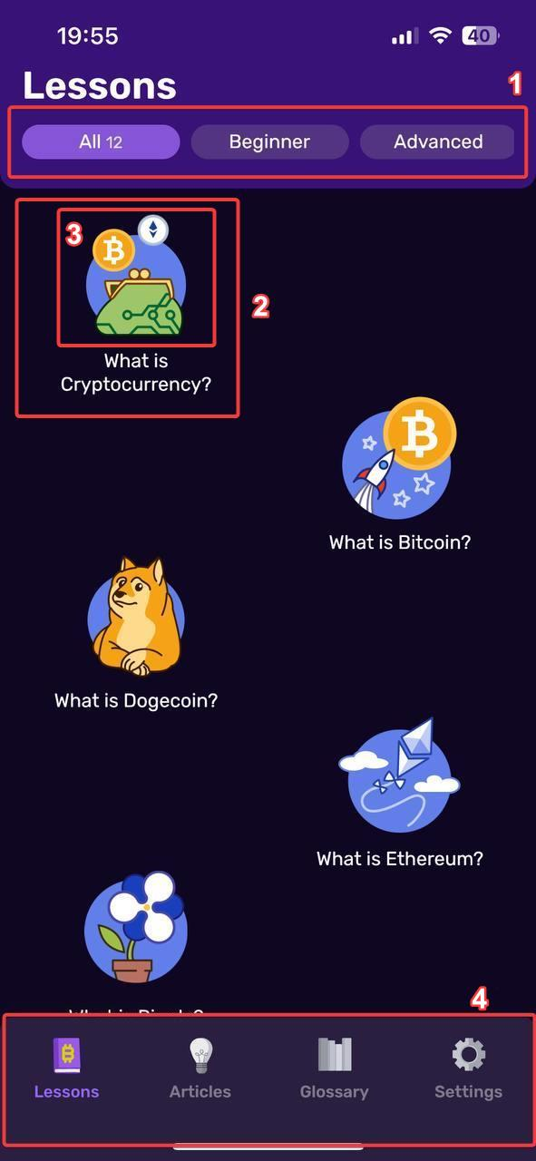

1.Top tab bar

1. Tab [All] (12)
2. Tab [Beginner] (9)
3. Tab [Advanced] (3)

2. Lesson item

3. Lesson Icon

4. Bottom tab bar

1. Tab [Lessons]
2. Tab [Articles]
3. Tab [Glossary]
4. Tab [Settings]

**Note! The number of included Lesson buttons is shown in the active tab.**

**2.2. Lesson start screen**

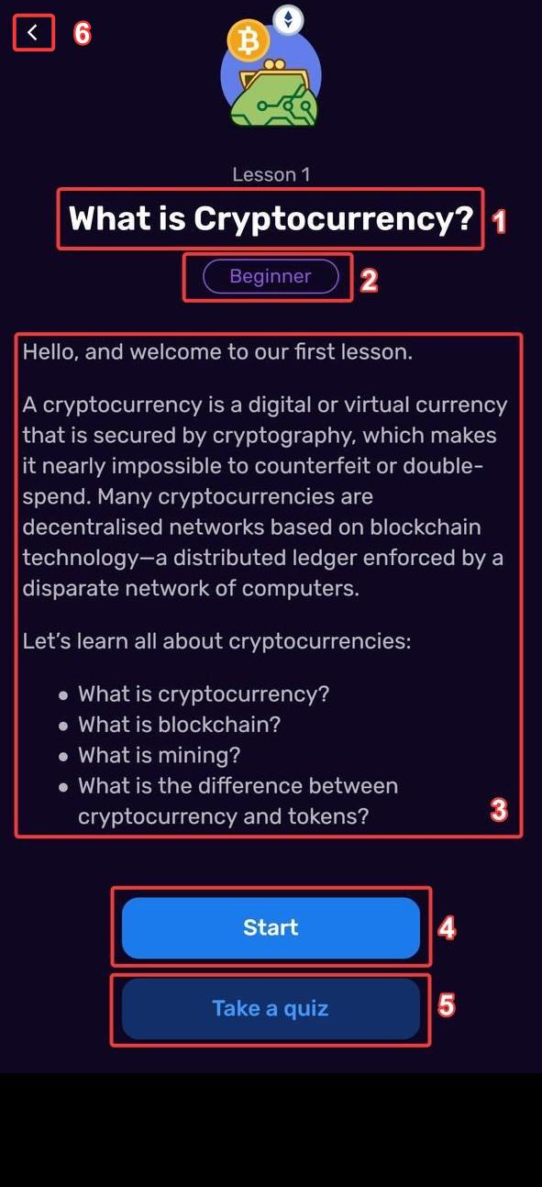

1. Lesson title
2. Difficulty level
3. Lesson summary
4. Button [Start]
5. Button [Take a quiz]
6. Button [Return]

**2.2.1. Lesson module**

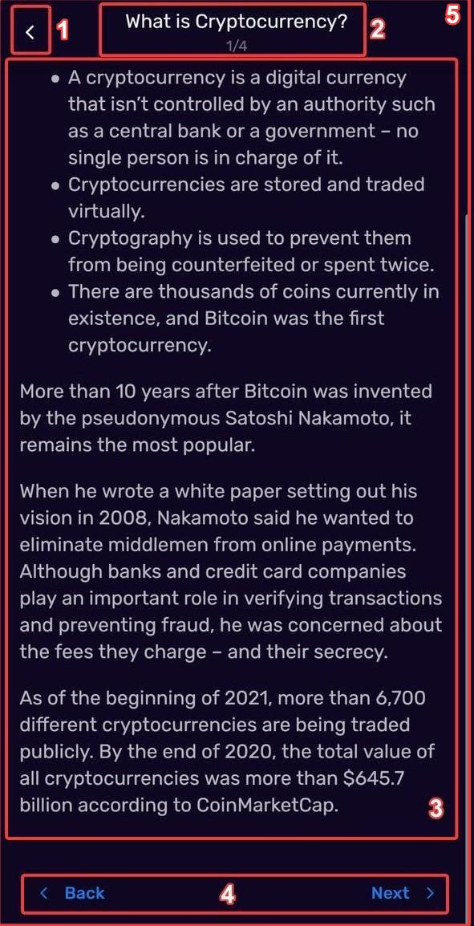

1. Button [Return]
2. Lesson title
3. Lesson content
4. Navigation button block [Back] and [Next]
5. Lesson module screen

**2.2.2. Quiz module**

|  |  |  |
| --- | --- | --- |
|  |  | |
| 1) If the user selects the incorrect option: | 2) If the user selects the correct option: | |
|  | |  | |
| 1. Button [Close]  2. Progress bar  3. Quiz question  4. Answer options  5. Wrong Answer cell  6. Correct Answer cell  7. Action sheet  8. Button [Continue]  9. Quiz module screen |  | |

**Quiz result screens**

|  |  |
| --- | --- |
| Quiz failed | Quiz passed |
|  |  |
| 1. Result screen 2. Score bar 3. Button [Close] 4. Button [Try again] 5. Button [Read lesson] | 1. Result screen  2. Score bar  3. Button [Close]  4. Button [Go to lessons] |

1. **Articles**

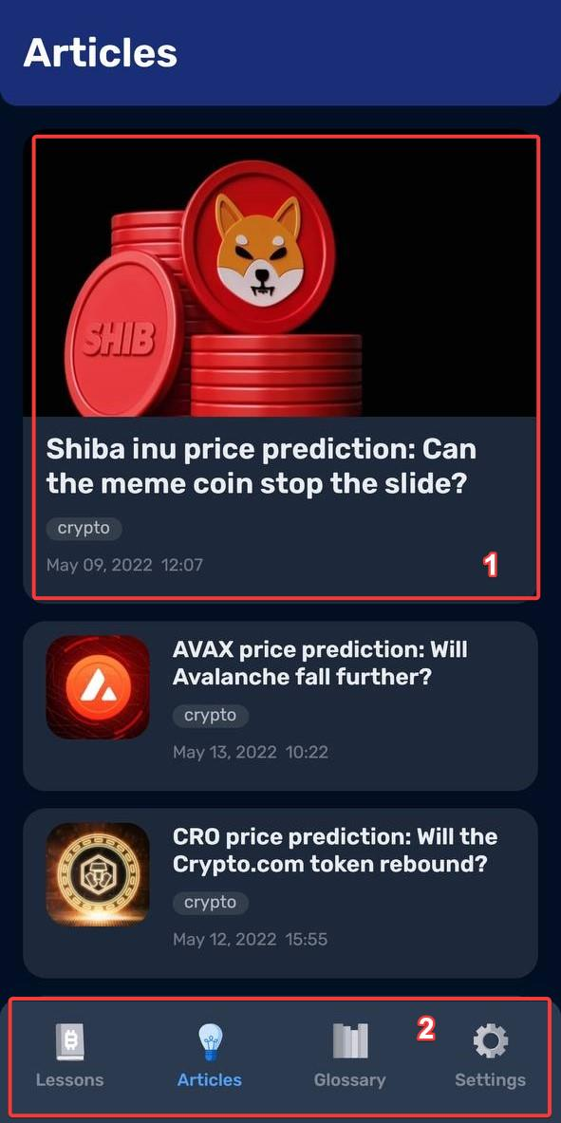

1. Article card

2. Bottom tab bar

1. Tab [Lessons]
2. Tab [Articles]
3. Tab [Glossary]
4. Tab [Settings]

**3.1. Article screen**

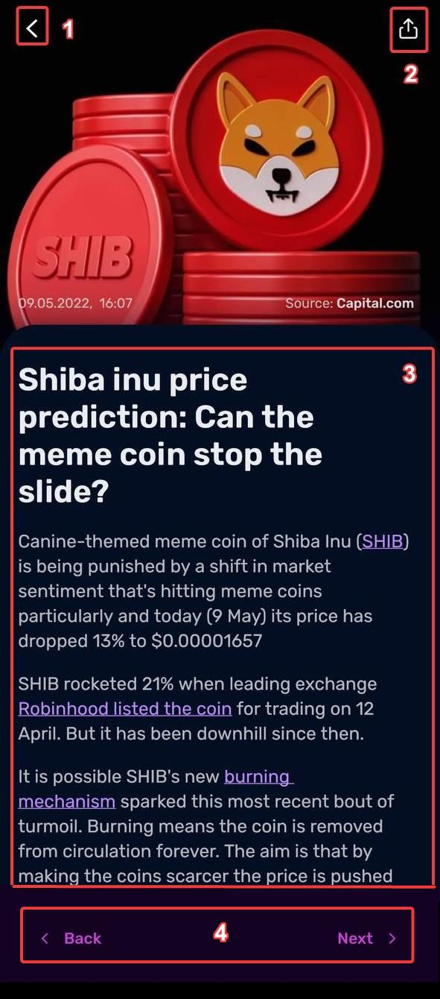

1. Button [Return]
2. Button [Share]
3. Article content
4. Navigation buttons:
5. button [Back]
6. button [Next]
7. **Glossary**

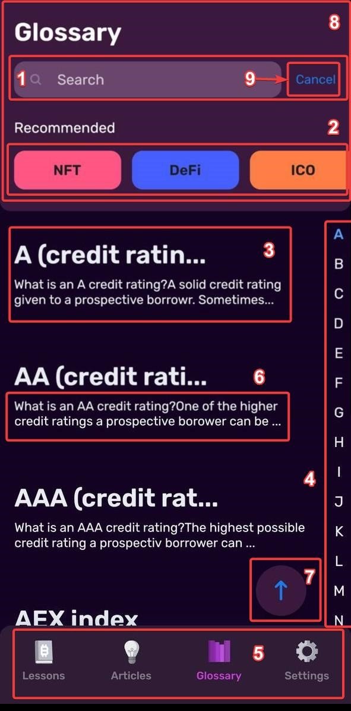

|  |  |
| --- | --- |
| 1. Search field  2. Tab [Recommended]  3. Term [A]  4. Alphabet scroll list  5. Bottom tab bar   1. Tab [Lessons] 2. Tab [Articles] 3. Tab [Glossary] 4. Tab [Settings] | 6. Preview Text  7. Button [Up]  8. Header [Search/Recommended]  9. Button [Cancel] |

**4.1. Term screen**

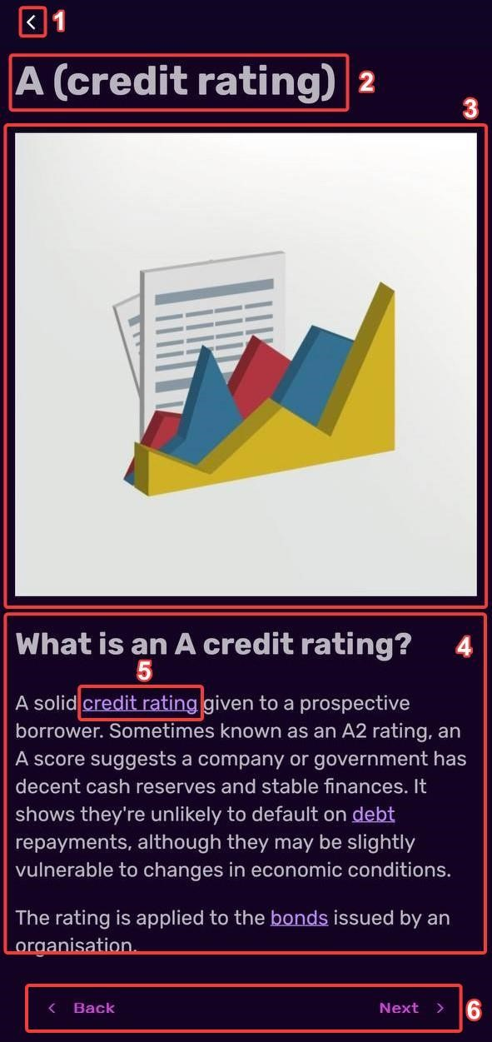

1. Button [Return]
2. Title
3. Image
4. Term content
5. Link [Capital.com]
6. Navigation buttons:

a) button [Back]

b) button [Next]

1. **Settings**

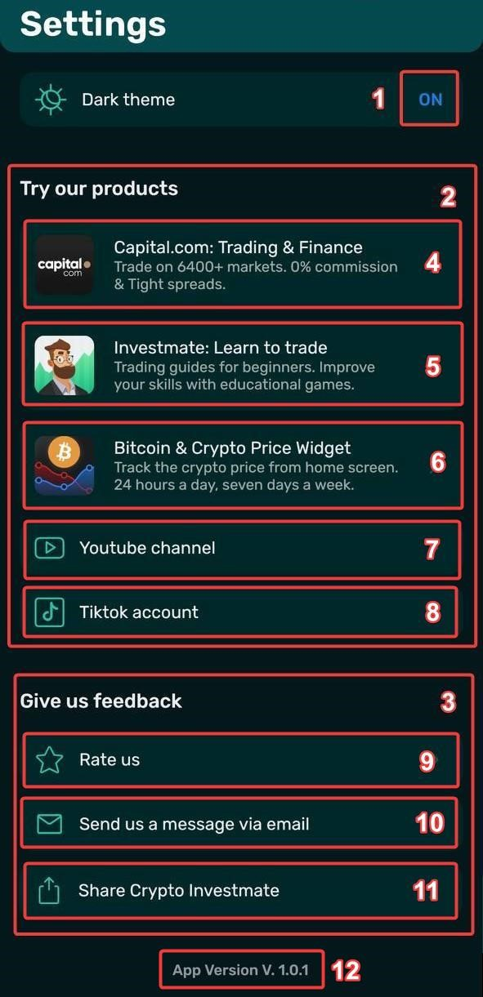

|  |  |
| --- | --- |
| 1. Toggle.  "Dark theme"  toggle button (“ON” by default)  2. Application block [Try our products]  3. Feedback block [Give us feedback]  4. Cell [Capital.com: Trading & Finance]  5. Cell [Investmate: Learn to trade]  6. Cell [Bitcoin & Crypto Price Widget] | 7. Cell [Youtube channel] Social links  8.Cell [Tiktok account]  9. Cell [Rate us]  10. Cell [Send us a message via email] (To go to the mail sender)  11. Cell [Share Crypto Investmate]  (To go to the sharing options)  12. App version |

**5.2. Application block [Try our products]**

**Capital.com: Trading & Finance.**

Scenarios after tapping the item:

1. If the “Capital.com: Trading & Finance” app is installed and the user is logged in.

The app opens (in the “Cryptos” tab).

1. If the “Capital.com: Trading & Finance” app is installed and the user is logged out.

The app opens (in the “Login” form).

1. If the “Capital.com: Trading & Finance” app is not installed.

The Google Play Store / App Store opens (in the app downloading screen).

**Investmate: Learn to trade. (needs clarification)**

[For Android] The system notification “Open with Google Play Store”  opens after tapping the item:

1. “Just once” button
2. “Always” button

The “Investmate: learn to trade” screen opens on the Google Play Store.

[For IOS]:

The “Investmate: learn to trade” screen opens on the Apple Store.

**Bitcoin & Crypto Price Widget. (only IOS?)**

**5.3. Social links**

**YouTube channel.**

The home screen of “Capital.com” channel  opens on YouTube.

**TikTok account.**

The main screen of “Capital.com” opens on TikTok.

**5.4. Feedback block [Give us feedback]**

**Rate Us**

**Dark Theme**

|  |  |
| --- | --- |
|  |  |
| 1. Emoji Status “Sad”  2. Reaction Block  3. Button [Leave a review]  4. Button [Contact us via email]  5. Button [Maybe later]  6. Return button | 1. Emoji Status “Happy”  2. Reaction Block  3. Button [Leave a review]  4. Button [Contact us via email]  5. Button [Maybe later]  6. Return button |

**Light Theme**

|  |  |
| --- | --- |
|  |  |
| 1. Emoji Status “Sad”  2. Reaction Block  3. Button [Contact us via email]  4. Button [Maybe later]  5. Return button | 1. Emoji Status “Happy”  2. Reaction Block  3. Button [Contact us via email]  4. Button [Maybe later]  5. Return button |